EnchantedLearning.com
Outline Map of the Middle East
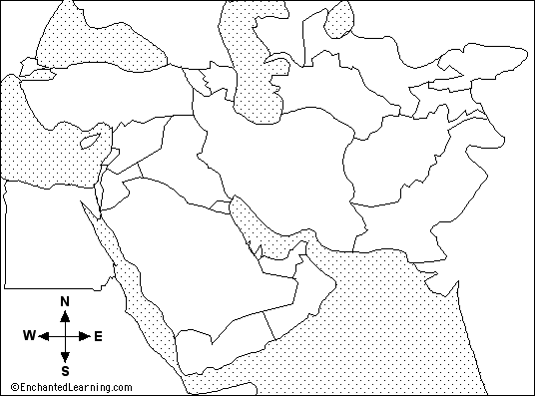

Label the following
Saudi Arabia Egypt
Israel Syria
Kuwait Yemen
Iraq Oman
Iran Lebanon
Jordan Afghanistan
Turkey Pakistan

